]SCHOOL OF COMPUTER SCIENCE AND ARTIFICIAL INTELLIGENCE |  |  |  |  | DEPARTMENT OF COMPUTER SCIENCE ENGINEERING
ProgramName:B. Tech |  |  |  | Assignment Type: Lab |  |  | AcademicYear:2025-2026
CourseCoordinatorName |  |  |  | Venkataramana Veeramsetty
Instructor(s)Name |  |  |  | Dr. V. Venkataramana (Co-ordinator)  Dr. T. Sampath Kumar  Dr. Pramoda Patro  Dr. Brij Kishor Tiwari  Dr.J.Ravichander  Dr. Mohammand Ali Shaik  Dr. Anirodh Kumar  Mr. S.Naresh Kumar  Dr. RAJESH VELPULA  Mr. Kundhan Kumar  Ms. Ch.Rajitha  Mr. M Prakash  Mr. B.Raju  Intern 1 (Dharma teja)  Intern 2 (Sai Prasad)  Intern 3 (Sowmya)  NS_2 ( Mounika)
rCourseCode |  |  | 24CS002PC215 | CourseTitle |  | AI Assisted Coding
Year/Sem |  |  | II/I | Regulation |  | R24
Date and Day  of Assignment |  |  | Week5- Wednesday | Time(s)
Duration |  |  | 2 Hours | Applicableto  Batches
AssignmentNumber:9.3(Present assignment number)/24(Total number of assignments)
 | Q.No. | Question |  |  |  |  |  | ExpectedTime  to complete
 | 1 | Lab 8: Documentation Generation: Automatic documentation and code comments  Lab Objectives:  - To understand the importance of documentation and code comments in software development.  - To explore how AI-assisted coding tools can generate meaningful documentation and inline comments.  - To practice generating function-level and module-level docstrings automatically.  - To evaluate the quality, accuracy, and limitations of AI-generated documentation.  - To develop a small automated tool for documentation generation in Python..  Lab Outcomes (LOs):  After completing this lab, students will be able to:  - Apply AI-assisted coding tools to generate docstrings and inline comments for Python code.  - Critically analyze AI-generated documentation for correctness, completeness, and readability.  - Create structured documentation (function-level, module-level) following standard formats.  - Design and implement a mini documentation generator tool to automate code commenting and docstring creation.  Task Description#1 Basic Docstring Generation  - Write python function to return sum of even and odd numbers in the given list.  - Incorporate manual docstring in code with Google Style  - Use an AI-assisted tool (e.g., Copilot, Cursor AI) to generate a docstring describing the function.  - Compare the AI-generated docstring with your manually written one.  Expected Outcome#1: Students understand how AI can produce function-level documentation.  Task Description#2 Automatic Inline Comments  - Write python program for sru_student class with attributes like name, roll no., hostel_status and fee_update method and display_details method.  - Write comments manually for each line/code block  - Ask an AI tool to add inline comments explaining each line/step.  - Compare the AI-generated comments with your manually written one.  Expected Output#2: Students critically analyze AI-generated code comments.  Task Description#3  - Write a Python script with 3–4 functions (e.g., calculator: add, subtract, multiply, divide).  - Incorporate manual docstring in code with NumPy Style  - Use AI assistance to generate a module-level docstring + individual function docstrings.  - Compare the AI-generated docstring with your manually written one.  Expected Output#3: Students learn structured documentation for multi-function scripts  Push documentation whole workspace as .md file in GitHub Repository  Note: Report should be submitted a word document for all tasks in a single document with prompts, comments & code explanation, and output and if required, screenshots |  |  |  |  |  | Week4 - Wednesday

Task Description#1 Basic Docstring Generation
- Write python function to return sum of even and odd numbers in the given list.
- Incorporate manual docstring in code with Google Style
- Use an AI-assisted tool (e.g., Copilot, Cursor AI) to generate a docstring describing the function.
- Compare the AI-generated docstring with your manually written one.

Expected Outcome#1: Students understand how AI can produce function-level documentation

Prompt : Give me a python function to find and return the sum of even and odd numbers in the given list.

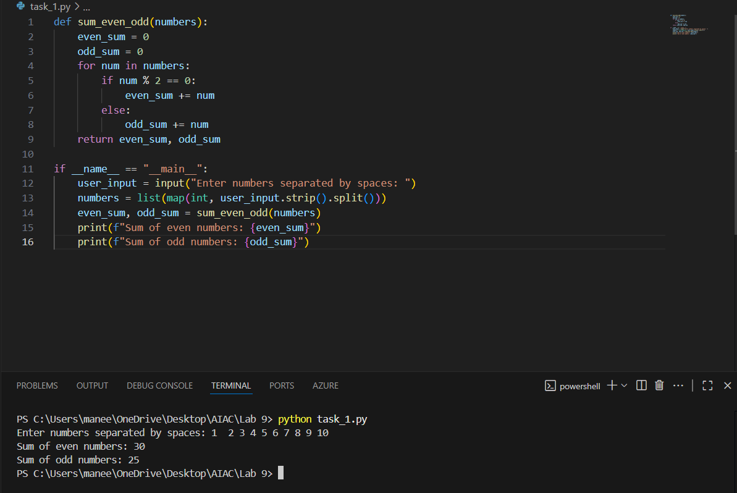

Manual docstring : It uses sum_even_odd as a function definition to return the sum of the even and odd numbers and it uses looping statement for finding the even numbers and odd numbers and return to the function.It takes user input and takes some of numbers and print the even and odd numbers.

AI generated docstring : 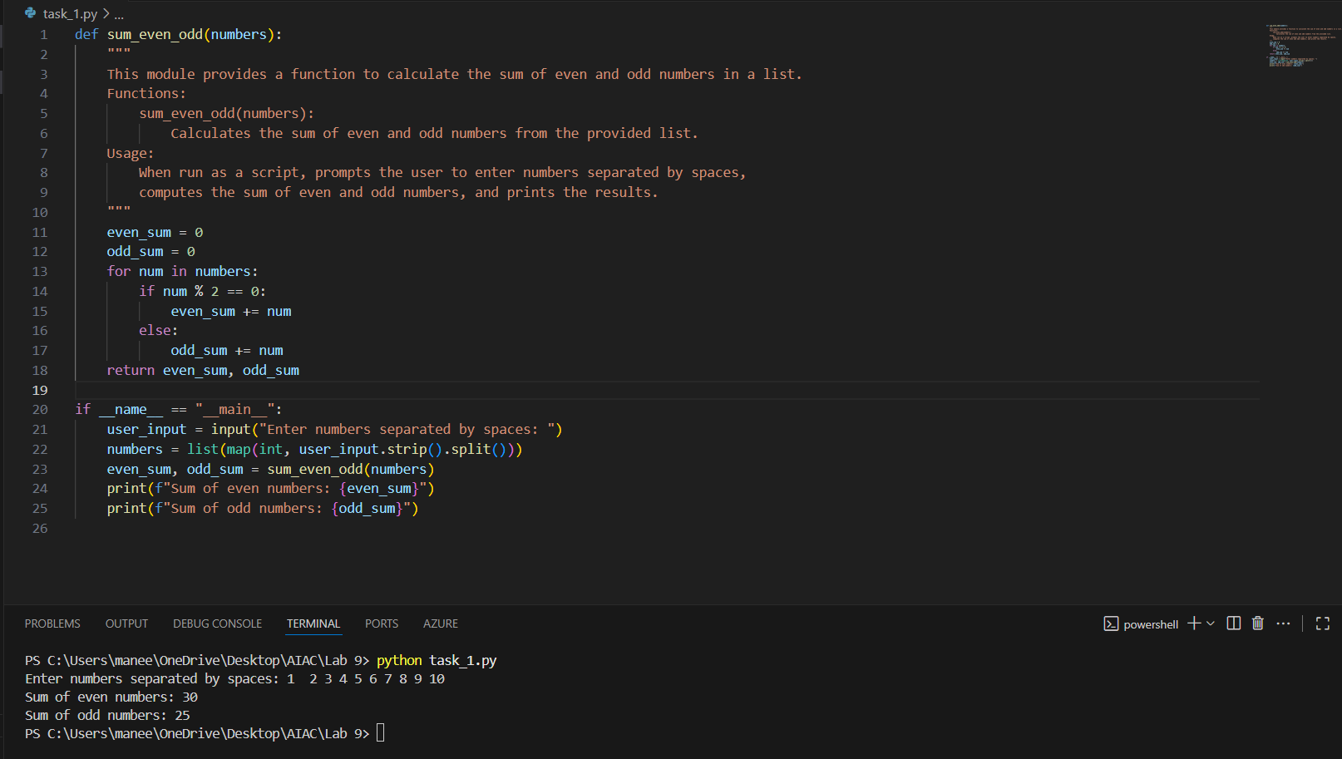

Task Description#2 Automatic Inline Comments
- Write python program for sru_student class with attributes like name, roll no., hostel_status and fee_update method and display_details method.
- Write comments manually for each line/code block
- Ask an AI tool to add inline comments explaining each line/step.
- Compare the AI-generated comments with your manually written one.

Expected Output#2: Students critically analyze AI-generated code comments.

Prompt : Give me a python code which genetrates a class named srustudent with attributes like name , roll no , hostel_status and fee_update method and display_details method

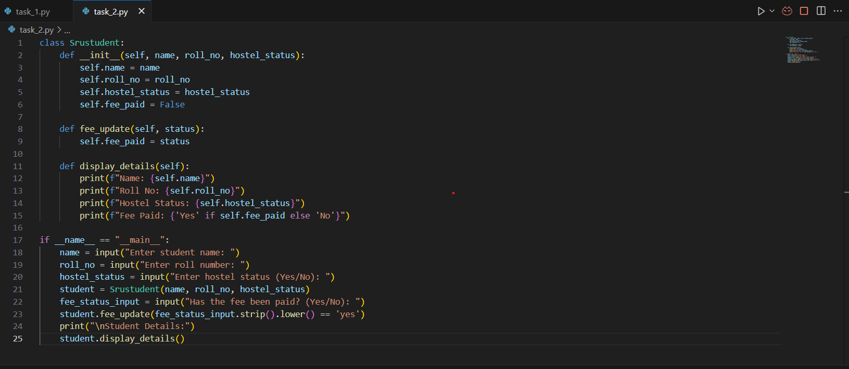

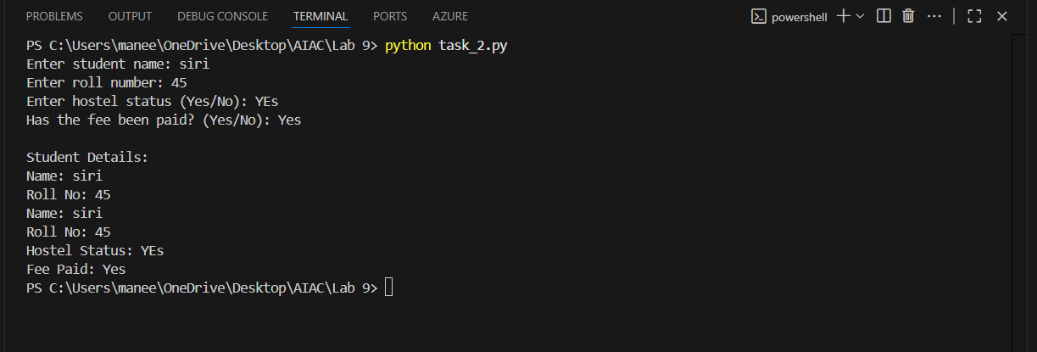

Manual docstring : A class of srustudent is created in that we have an attributes like name , roll no ,hostel staus and fee update as method .Fee updates the method .True if paid false if not paid

AI generated docstring :

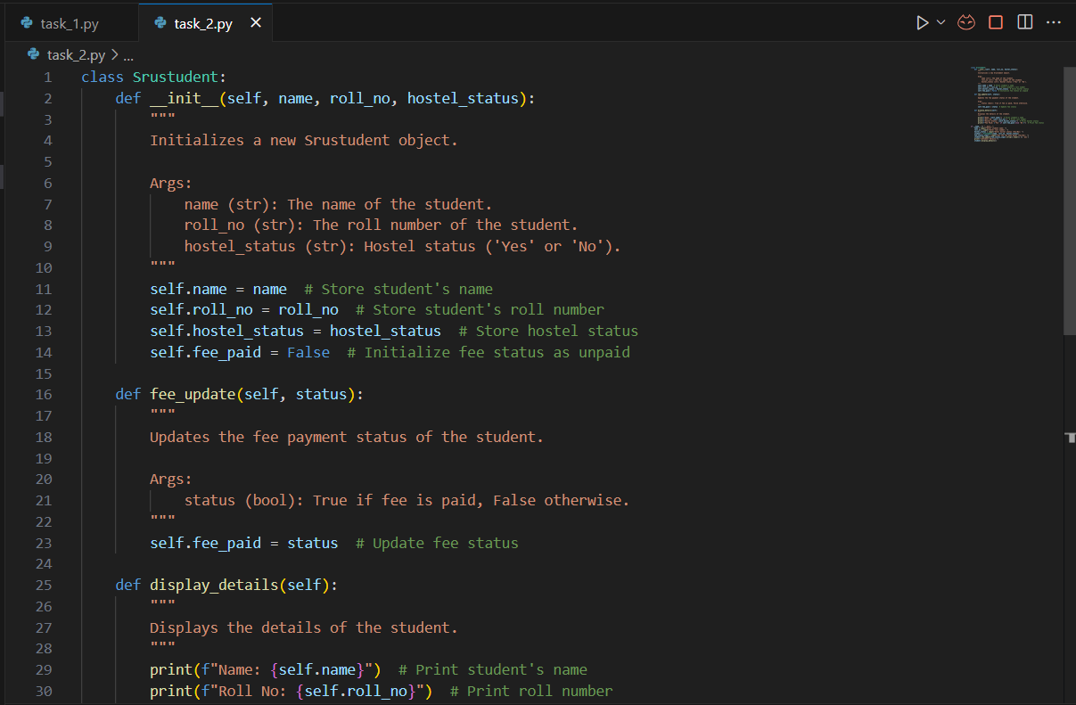

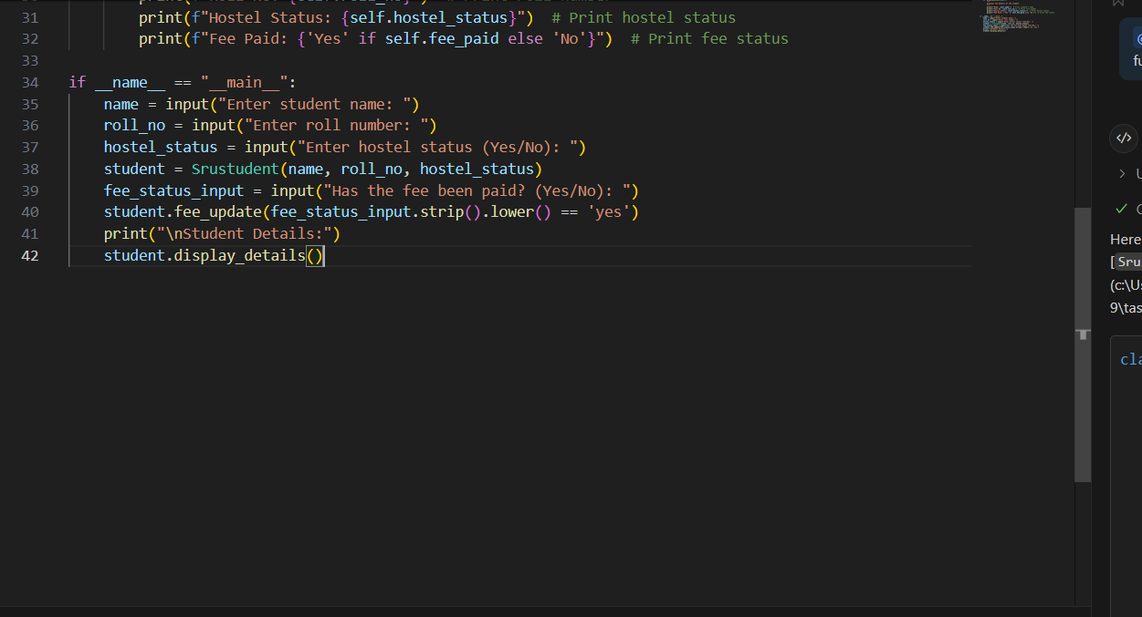

Task Description#3
- Write a Python script with 3–4 functions (e.g., calculator: add, subtract, multiply, divide).
- Incorporate manual docstring in code with NumPy Style
- Use AI assistance to generate a module-level docstring + individual function docstrings.
- Compare the AI-generated docstring with your manually written one.

Expected Output#3: Students learn structured documentation for multi-function scripts

Prompt : Give me a python function with 3 – 4 functions use calculator as a function and create ad, subtract , multiply and divide as sub function and return the value. 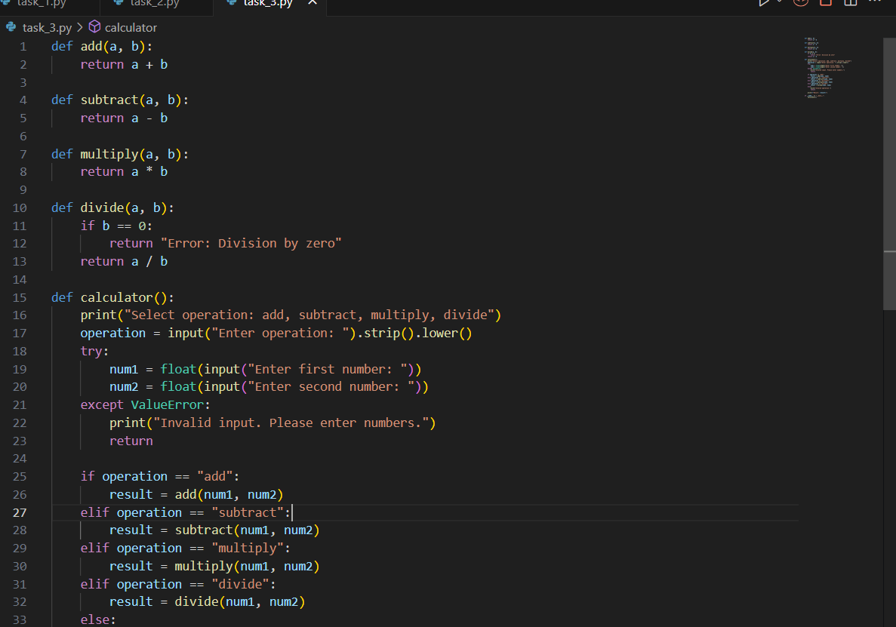

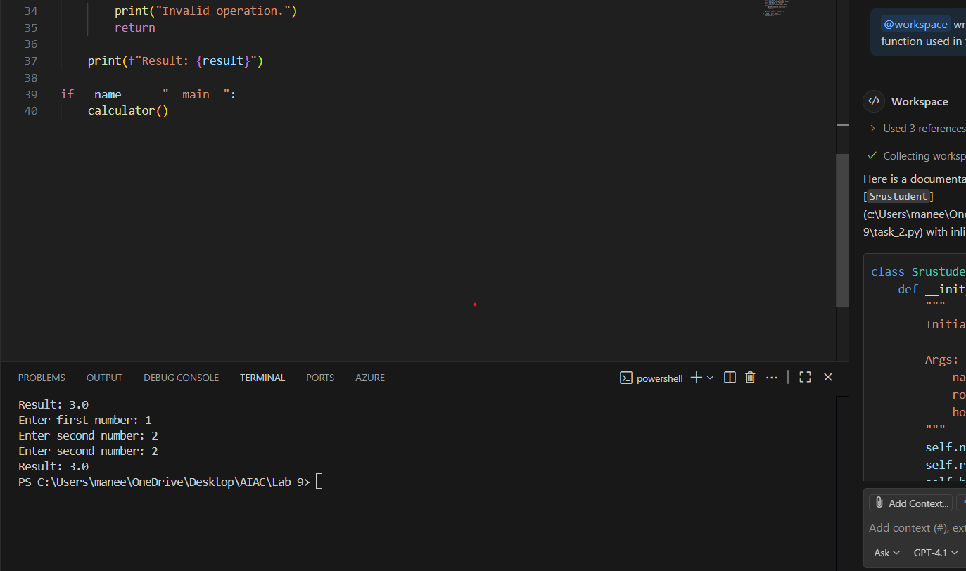

Manual docstring : A simple python program where it creates a calculator function and defines four different functions in calculator add, sub, mul and div .It takes input as two numbers and we need to select which function it need to excute and it excutes and return back to that function.

AI generated docstring :
